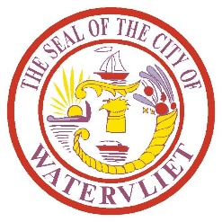
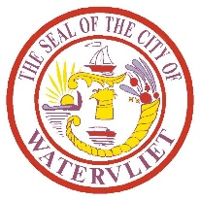
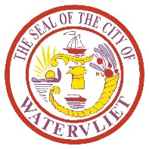
AGENDA
CITY OF WATERVLIET COUNCIL MEETING
Thursday, September 17, 2026

6:00 PM

REPORT OF OFFICERS AND COMMITTEES
OLD BUSINESS
NEW BUSINESS

PUBLIC HEARING – A hearing for those persons who wish to be heard regarding proposed Local Law No. 6 for 2026 which is a local law amending section of the Code of the City of Watervliet regarding Garages, Carports, and Rear Setbacks.

PUBLIC HEARING – A hearing for those persons who wish to be heard regarding proposed Local Law No. 7 for 2026 which is a local law amending sections of the Code of the City of Watervliet regarding fees.

PUBLIC HEARING - A hearing for those persons who wish to be heard regarding proposed Local Law No. 8 for 2026 which is a local law amending sections of the Code of the City of Watervliet regarding zoning.

LOCAL LAW No. 6 for 2026 – A Local Law amending sections of the Code of the City of Watervliet regarding Garbage, Carports and Rear Setbacks.

LOCAL LAW No. 7 for 2026 – A Local Law amending sections of the Code of the City of Watervliet regarding fees.

LOCAL LAW No. 8 for 2026 – A Local Law amending sections of the Code of the City of Watervliet regarding zoning.

ORDINANCE No. 16 for 2026 – An Ordinance to amend section 260-30C by repealing Ordinance 1950 adopted November 12, 2015, and directing the Department of Public Works to remove a handicap parking sign in front of 415 Seventh Avenue.

RESOLUTION No. 65 for 2026 – A Resolution establishing a Capital Account for the purchase of Recycling Trucks using New York State Department of Environmental Conservation (‘NYSDEC’) Recycling Grant Funds.

RESOLUTION No. 66 for 2026 – A Resolution authorizing the purchase of a Caterpillar Model 305 Excavator with Flail Mower Attachment

RESOLUTION No. 67 for 2026 – A Resolution establishing a Capital Account for the 2026 Seasonal Paving Project and Curb Installation Program.

APPROPRIATIONS AND ACCOUNTING

PUBLIC COMMENT PERIOD

Next Meeting: Thursday, October 1, 2026
Watervliet Cultural Center

