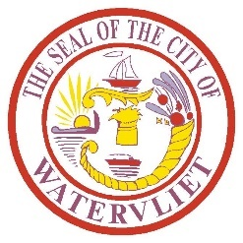
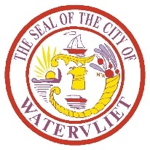
AGENDA
CITY OF WATERVLIET COUNCIL MEETING
Thursday, DECEMBER 15th, 2022

6:00 PM

REPORT OF OFFICERS AND COMMITTEES

OLD BUSINESS

NEW BUSINESS

PRESENTATION – Comprehensive Plan Update

Call Public Hearing January 19th, 2023 - Comprehensive Plan Update

RESOLUTION 80 for 2022 - A RESOLUTION AWARDING A CONTRACT FOR THE REPLACEMENT OF STEAM BOILER AT THE WATER FILTRATION AND AUTHORIZING MAYOR CHARLES V. PATRICELLI TO EXECUTE ALL REQUIRED DOCUMENTS REGARDING SAME

RESOLUTION 81 for 2022 - A RESOLUTION AMENDING A CONTRACT FOR REPAIRS TO THE CITY
HALL SOFFIT FASCIA REPAIR PROJECT AND AUTHORIZING MAYOR CHARLES V. PATRICELLI TO
EXECUTE ALL REQUIRED DOCUMENTS REGARDING SAME

RESOLUTION 82 for 2022 - A RESOLUTION AMENDING THE ANNUAL BUDGET FOR FISCAL YEAR
2022

RESOLUTION 83 for 2022 - A RESOLTION TO AMEND AN AGREEMENT WITH GALLO
CONSTRUCTION CORP. REGARDING THE SPRAY POOL/SPLASH PAD PROJECT AND AUTHORIZING MAYOR CHARLES V. PATRICELLI TO EXECUTE ALL REQUIRED DOCUMENTS REGARDING SAME

RESOLUTION 84 for 2022 - A RESOLUTION ACCEPTING A DONATION IN THE AMOUNT OF
$6,554.90 FROM WATERVLIET CHARITABLE FOUNDATION TO BE USED FOR SAFETY AND
RECREATIONAL PROJECTS

RESOLUTION 85 for 2022 - A RESOLUTION ACCEPTING A DONATION IN THE AMOUNT OF $2,000.00 FROM WATERVLIET HISTORICAL SOCIETY TO BE USED FOR CONSTRUCTION OF THE CRINIGAN BELL MONUMENT

APPROPRIATIONS AND ACCOUNTING

PUBLIC COMMENT PERIOD

*NEXT MEETING January 5th, 2023

